π

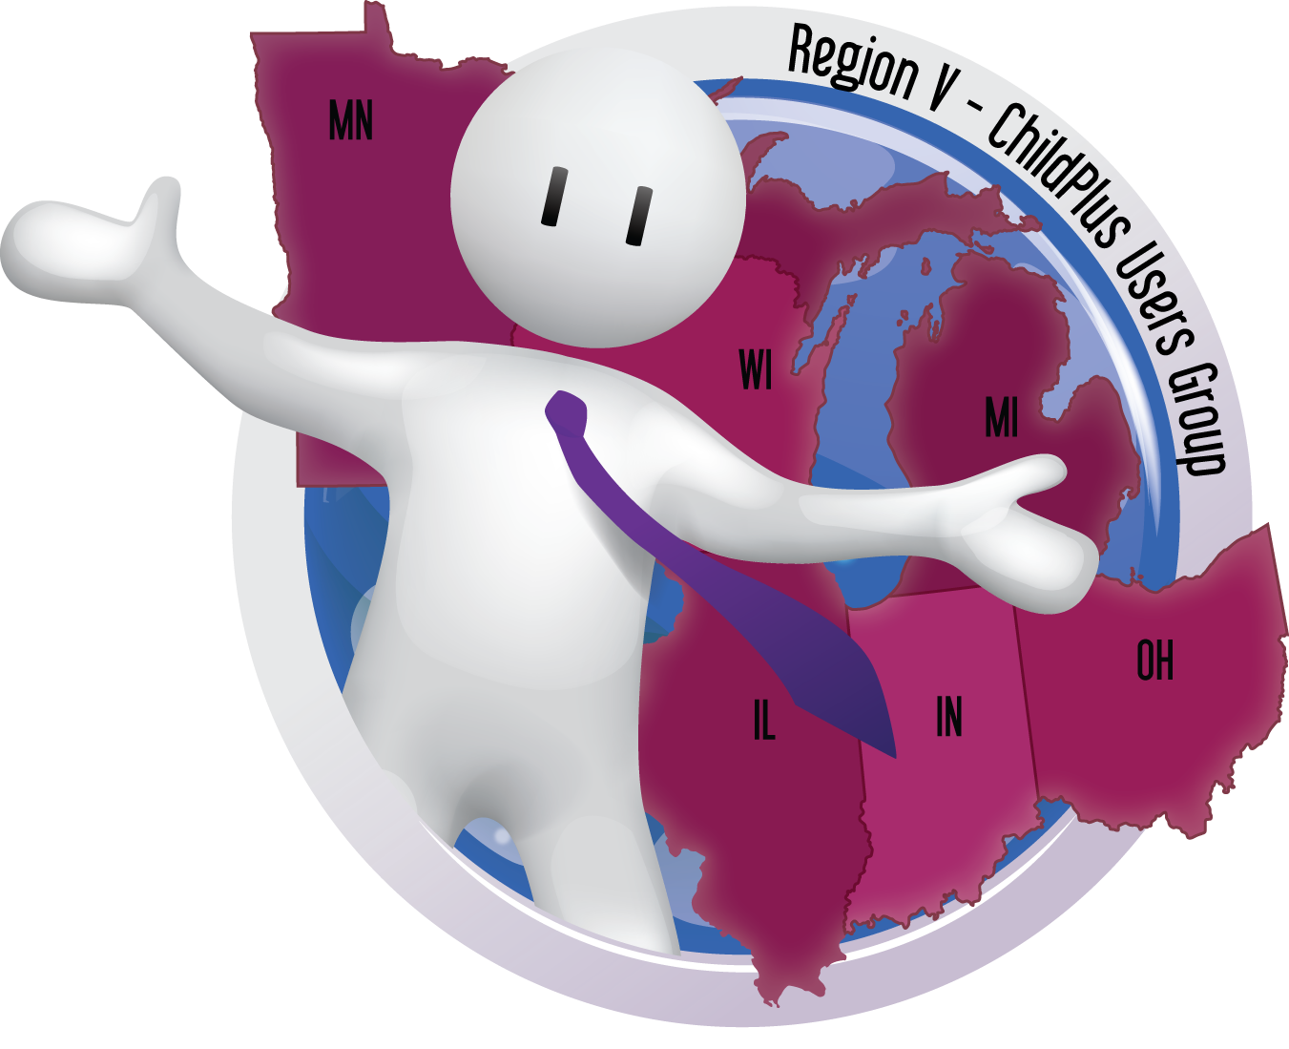

**ChildPlus Region V Meeting**

Minnesota, Wisconsin, Illinois, Indiana, Michigan & Ohio

**Users coming together to troubleshoot problems, offer tips, shortcuts, and to suggest possible ways to improve upon the nation’s leading Head Start software.**

**Users meet at Child and Family Centers of Excellence, N4W22000 Bluemound Rd., Waukesha, WI 53186. If you have questions, contact Linda LaFuente at 262-521-0321 or** [**lindal@excellencecenters.com**](lindal@excellencecenters.com)**.**



**ChildPlus Region V Meeting**

**April 23 - 24, 2020**

*(Check-in 8:30-9:00 a.m.)*

April 23, from 9:00 to 3:30

April 24, from 9:00 to 3:30

ChildPlus Users;

The bi-annual ChildPlus Region V Meeting has been scheduled. To register for this event, you must use the attached registration form and email, snail-mail, or fax it to Linda at the number below.

Bring your laptop, your questions, your suggestions, and your expertise. This meeting is controlled at your pace. No need to worry that you missed something; we’re happy to go over it again!

Relax at our casual setting located at Child & Family Centers of Excellence, N4W22000 Bluemound Rd., Waukesha, WI. There will be a tour of our one-of-a-kind facility for those interested.

**Lunch will be on your own however, coffee and soda will be provided.**

Use the attached registration form and submit your registration no later than April 15, 2020. The registration form may be copied as needed.

Sign up now; April is almost here!

Hope to see you there,  
Linda

Linda LaFuente  
Region V ChildPlus Facilitator  
National Centers for Learning Excellence   
Information Systems Manager, Senior Enrollment Spec., Database Admin., Family Services Spec., Desktop Publisher

**ChildPlus Region V Meeting | Registration Form**

**April 23 - 24, 2020**

*(Check-in 8:30-9:00 a.m.)*

April 23, from 9:00 to 3:30

April 24, from 9:00 to 3:30

**Agency name: _______________________________________________________________________________________________________**

**Agency address: _____________________________________________________________________________________________________**

**City: __________________________________________________________ State: ______________________ Zip: _____________________**

**Agency phone: ______________________________________________________________________________________________________**

**Name: E-mail address:**

**Number attending: ____________________________**

**NOTE: Lunch will not be available for this event.**

**Send registration to (FAX) 262-548-8084 or (Email)** [**lindal@excellencecenters.com**](mailto:lindal@excellencecenters.com)

**Registration will be closed early if maximum attendance is achieved.**

***Child and Family Centers of Excellence, Inc.,***

***N4W22000 Bluemound Rd.,***

***Waukesha, WI 53186***

For more information please contact Linda LaFuente at 262-521-0321 or email her at [lindal@excellencecenters.com](mailto:lindal@excel-lencecenters.com).

**ChildPlus Region V Meeting**

Minnesota, Wisconsin, Illinois, Indiana, Michigan & Ohio

**Users coming together to troubleshoot problems, offer tips, shortcuts, and to suggest possible ways to improve upon the nation’s leading Head Start software.**